Giovanni Careri
Fellow at the Italian Academy, Columbia University ,Spring 2025.
3/26/2025
Annibale Carracci. Painting as theoretical object.

The work I'm doing at the moment at the Italian Academy is part of a larger project that consists of constructing a series of paintings by Annibale Carracci, made in Bologna in the eighties of the sixteenth century, before his move to Rome in 1596.
The term series should be understood here in the sense of structuralist analysis, that is: the linking of objects that share some pertinent features and present themselves as a coherent whole of relationships and transformations. The model for this type of approach is the analysis of Kwakiutl masks by Claude Lévi-Strauss, who maintained that a mask is not primarily what it represents, but what it transforms with respect to the other masks in the series. By calling his research objects “theoretical objects”, the philosopher and art historian Hubert Damisch indicate a form of seriality very similar to that constructed by Lévi-Strauss as far as he attributes to the term theory the original Greek sense of the procession of the teoroi in ritual ceremonies. What counts is the role and position of the term in the series of transformations in which it participates and not the meaning of each term considered in isolation. According to Damisch, theory is produced in history but cannot be reduced to it, as happens, for example, with scientific discoveries that have effects far beyond the historical moment in which they were made.
Since my first book on Bernini's three Roman chapels (1990), I have worked in this perspective in an attempt to show that some works or series of works are not the mere effect of the historical context, but are themselves capable of producing effects that are not limited to the moment of their production. This approach shows how the artworks 'think' through the relationships they establish between themselves, thus requiring a close analysis and a construction of complexity based on singularities. For this reason, the paper that I will present next Wednesday will not have the synthetic and historicist character typical of a part of traditional art history, but an analytical, experimental and self-reflexive dimension, which tests the resistance of the series and leads to a modification of the theoretical assumptions that allowed its construction. It is an approach similar to that of experimental physics, which cannot proceed with experiments without resorting to existing theories, but whose experimental results oblige the theoretical physicist to conceive new parameters and modify the theory.
To avoid misunderstandings, I would like to point out that this approach, which falls within some of the paradigms of European semiotics, does not presuppose that images are conceivable as a general system of differences similar to that of language. The systematicity of the theoretical object is limited and local, but no less effective from a heuristic point of view.
The first characteristic of the series that interests me is its apparent incongruity: how can you hold together a Crucifixion, two butcher's shops, a peasant's meal, a devotional image and a self-portrait 'with family'? It is not possible for me to answer this question without getting closer to the paintings in question, however I will leave the two butcher's shops aside to avoid boring repetitions and to save some surprises.

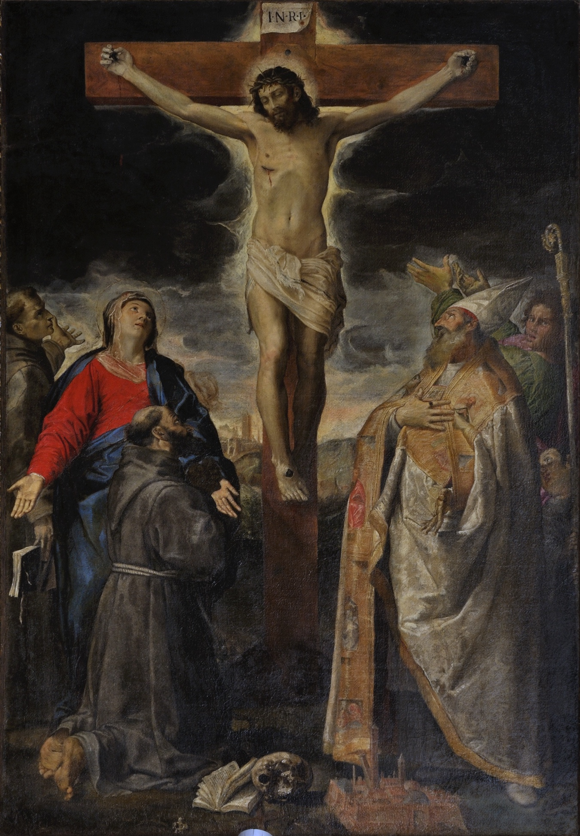Fig.1

A first relevant feature common to the series is a form of relationship with the spectator that consists of an invitation to “do” and not just to look: in the Annibale’s Crucifixion of 1583 (fig.1) a book is placed on the lower edge of the painting. This book, probably a Bible or a collection of Gospels, opens from right to left, and is therefore meant to be picked up and opened by the spectator, who can read the story of the Passion with deep devotion, to the point of having a vision of the Crucifixion, as is happening to St. Francis in the painting.
The operation that governs this specific form of imitation of the saint is defined by Christian theology as conformation: an assumption of resemblance to Christ of which Francis was the undisputed champion, to the point of receiving the stigmata on Mount of the Verna. The spiritual condition of conformation has been translated by painters as bodily and gestural imitation. It is a mimetic process that has nothing to do with mimesis understood as the reproduction of reality. Conformation informs a part of Christian art in different way, particularly innovative, however, between the sixteenth and seventeenth centuries. With a few important exceptions (Askew) conformation is nevertheless absent from the analytical discourse of art history, whereas it constitutes one of the essential elements of my work.
The Crucifixion is an altarpiece that is still on display in a church today. Saint Francis is kneeling like the devotee on the pews in front of the altar and thus offers himself in a postural and bodily imitation that participates in the spiritual and sensorial journey proposed to the spectator. It should be noted that in this painting the vision of the Cross is presented in connection with reading. The other Franciscan present in the painting, St. Bernardine, is also holding between his fingers a book that is falling, as was the case with the book that St. Francis was holding before letting it fall, so that we can consider the relationship between the two friars a sequence that describes the abandonment of reading in favor of a vision in which the bodily presence of Christ is situated beyond the limit of what reading can produce. The superiority of painting over writing, despite their intimate proximity, is another of the relevant features of the series, as we shall see.
The scene depicted has complex narrative and spatiotemporal characteristics as far as it oscillates between the genre of the “historical painting”, which situates the event in the past and near Jerusalem, and the genre of the “devotional painting” that brings the event up to date in the here and now of the spectator's experience through the mediation of saints who were not present at the time of the Crucifixion and place it in Bologna.

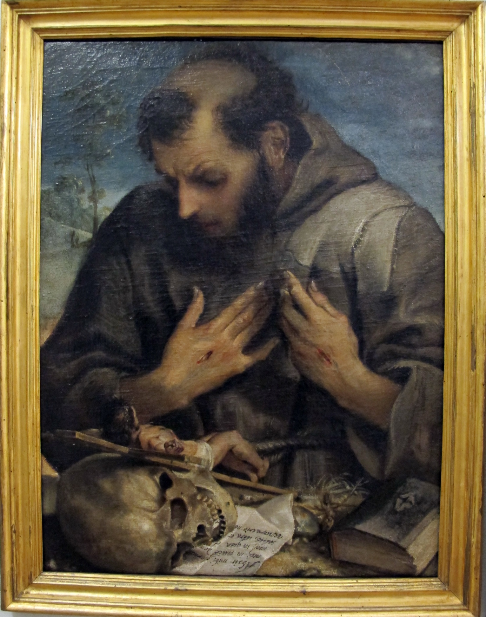Fig.2

The Penitent St. Francis in the Capitoline Museums (fig.2) presents a comparable oscillation; it is difficult to place the scene at a specific moment in the saint's life, while, here too, the actualization is at work, addressing the here and now of the spectator's experience. In this painting too, the book is available to the spectator like the cilice, an invitation to mortification. This painting implies a theory of the effectiveness, or agency, of the Christian image. Francis is here a spectator contemplating an artifact, the crucifix, which we can consider as an exemplary Christian work of art. You may have noticed that the crucified Christ, which should be made of wood or bronze, has the appearance of a body of flesh and raises his head and one leg to approach the saint. St. Francis, for his part, touches his tunic with the tips of his hands in an area that is becoming stained with blood. His face expresses the extreme surprise of having incorporated Christ and of sharing his martyrdom in an intense pain touching his “living” wound, as is said of a freshly opened wound. In other words, Francis conforms to the crucified Christ he is contemplating and offers himself, at the same time, to the imitation or conformation of the devotee-spectator, inviting him to take his place in the painting. The Christian image, this painting says, must induce the spectator to conform, producing an effect of presence so intense that it appears to be alive.
One of the most difficult objectives of my current research consists in the attempt to understand the meaning of the term vivo (alive) that Annibale Carracci uses to emphasize the painting of Titian that appears vive “alive” to him, a trait that escapes “the ignorant Vasari” []. The difficulty is linked to the topical character of this category that originates in Pliny's Natural Histories and that in artistic literature often overlaps with the category of vero (truth). To avoid the inhibiting effect of the topos, I decided to forgo analyzing the texts and concentrate on the paintings themselves, the result is certainly less general, but provide considerable specific evidence. In this perspective, I propose to compare Annibale's St. Francis with that of his greatest rival: Bartolomeo Passerotti (fig. 3).

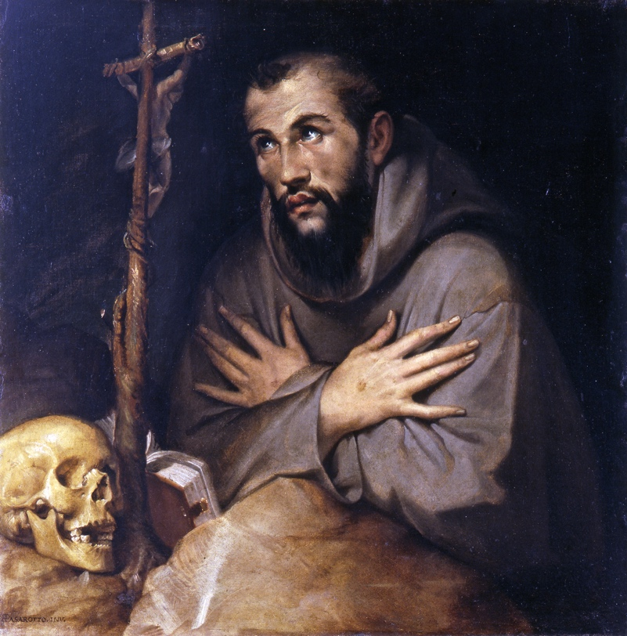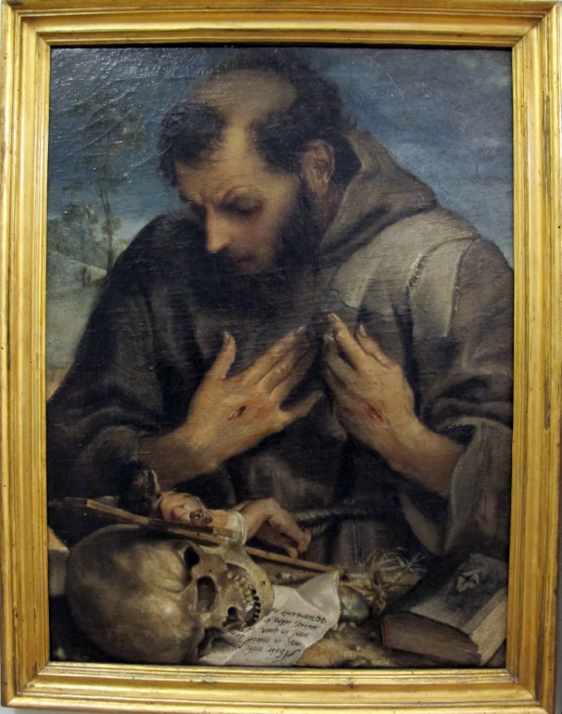
Fig.3
The two paintings probably date from the same year and are particularly suitable for comparison because of the similarity of the subject and the format. It is immediately apparent that the concept of vero “the truth” is not very illuminating for grasping the differences, since both paintings are “convincing” in the way they imitate the characters and the things they show, provided that we agree on what “convincing” means, thus opening one of the most difficult questions in cognitive science and neuroscience.
The fundamental difference from the point of view of the vivo, appears when observing the opposition between the open body of Annibale's Francis and the closed one of Passerotti's. In Annibale’s Francis, the openings are not limited to the bleeding that can be seen through the stain on the jute, the open mouth and the stigmata, but are also manifested through the tears in the tunic. These lacerations acquire all their meaning in connection with the gesture of the hands that prolong the lips of the open wound on the saint's heart. This gesture of “self-affection” (Merleau-Ponty) is a powerful way of inviting us to attribute a body of flesh to the painted body we have before us, a sensitive body that thus becomes vivo (alive) as the crucified Christ becomes vivo before the eyes of Francis.
The body and tunic of St. Francis by Passarotti are perfectly closed, there are no tears in the fabric, the mouth is not open and the wounds on the hands have been sutured. Here the saint is associated and assimilated to the rock on which it rests because of its dense compact consistency and color that excludes any trace of the brush. This body/rock is petrified by the contemplation of the crucifix, the eyes are the place where something divine manifests itself in the immaterial form of reflection, rather than in the carnal incorporation of the crucified in Annibale's St. Francis. It therefore seems coherent that the Christ of the Crucifix in Passarotti's painting remains motionless while the one in Annibale's painting comes to life, incarnating itself in front of the saint's body. The vivo (living) here is not the vero (truth), but the construction of a figure that present herself as adhering to a biological, living, sensitive, mobile, intense and expressive bodily substrate. The texture of the pictorial medium expresses this sensitive materiality while the relationship with the divine is realized according to the Eucharistic model of incorporation. The figure of Passarotti, on the other hand, is isolated from his own body in a form of devotion that can be defined as insensitive or even purely spiritual, sealed, as it is, by the immaterial splendor of the light in his eyes, according to the model of ascetism: that of becoming pure spirit.

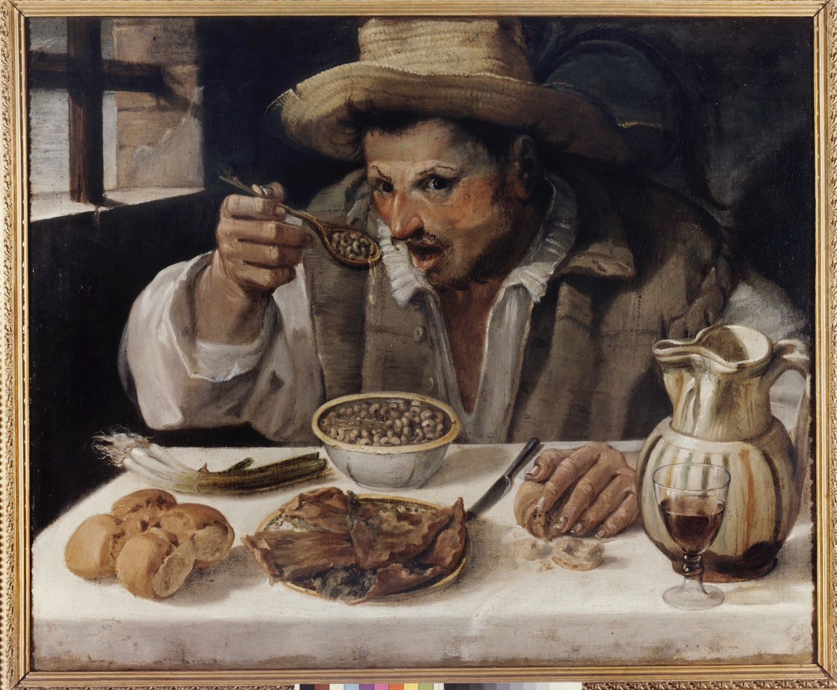
Fig.4

Until now we have been comparing paintings with a shared religious theme, introducing a painting depicting a peasant eating beans into the series is a more daring and apparently incongruous operation, but if we look at the “Mangiafagioli” (fig. 4) and keep in mind the role of books, we immediately see that the glass of wine placed on the edge of the table occupies a similar position. The peasants cannot take the glass that has just been placed on the table or is about to be taken by someone that has invaded his field of vision, as can be seen from the suspended gesture and the surprise. This scene cannot be understood without taking into account another – invisible – scene in front of the painting where the spectator has to find a place, as is the case in the Crucifixion and St. Francis [].
I would not have noticed the upside-down books in the Crucifixion and St. Francis if I hadn't already had the position and role of the glass in The Bean Eater clearly in mind. The association between these two completely different objects is based on the analogy between the devices used to implicate the spectator. The latter is not the empirical spectator but a sort of “lector in fabula” – according to Umberto Eco's definition: an implicit spectator produced by the painting itself. We could then describe this first relevant feature of the series in terms of a form of visual enunciation whose traces are inscribed in the painting itself in a way comparable to that of the deictics and pronouns that in conversation inscribe the positions of the speakers and the situation of the exchange of words [].
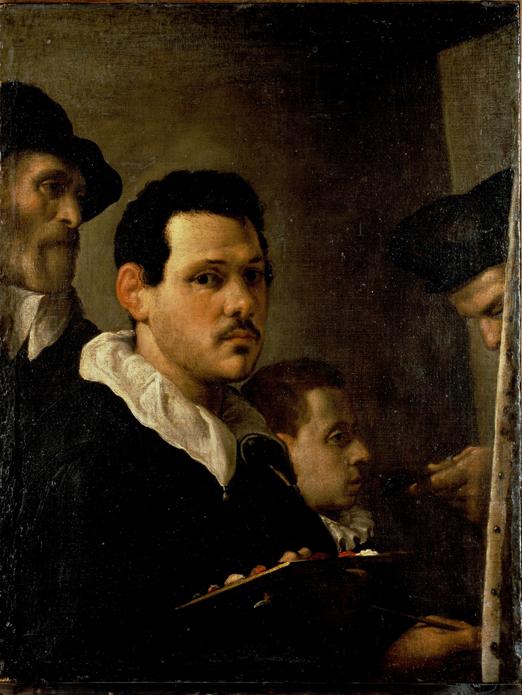

The series can be extended to the Self-Portrait with Figures in the Brera Museum in Milan, which shows Annibale in the act of portraying himself in the mirror in the company of his father, Antonio, his brother, Agostino, and a young nephew. The visibility of the studded side of the canvas and the right-left inversion of the hands holding the brush and the palette denounces the use of a mirror positioned at 90 degrees with respect to the painting.
The position of the spectator is here occupied by the painter who also assumes the role of model in front of the mirror. The other spectator, the one who will find himself in front of the finished painting, can put himself in the painter's shoes and accept his invitation to paint – another program of doing. However, in this painting, there is a significant detail in the gesture of the hand that protrudes from the canvas, of which we only see the side, and that is offering the young apprentice a spatula with a lump of blue pigment. His birretta (hat) could be that of a priest, so that gesture appears similar to that of the administration of the Eucharist. The colors arranged on Annibale’s palette are those used to paint flesh or skin tones, and the painter presents them to the spectator like food arranged on a plate. Here we see an association of pigment and food that is a recurring feature in my series, both in its most concrete and material form, and in the ritual form that assimilates painting to the Eucharist. In other words, the young apprentice is invited to ingest the Eucharistic pigment that associates him with the older members of the family. In the palette offered to the spectator one can see an invitation to consume the food pigment and enjoy the pseudo-Eucharistic effects of the painting.
It would be really difficult to support this extreme hypothesis if the recurrence proper to the series didn't come to the rescue.
Thus, in the Bean Eaters, the hand, the glass of wine and the broken bread are composed, with the surprise of the peasant in a constellation that brings out the memory of the supper at Emmaus where the bread is transubstantiated for the second time into the body and blood of Christ.

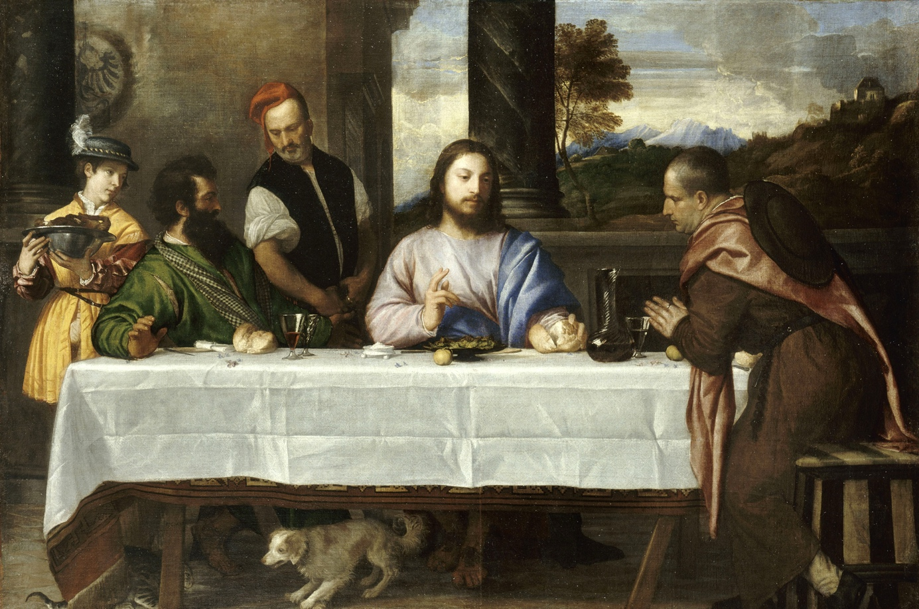
This memorial connection between an explicit image and a latent image, and between an ordinary gesture – such as painting or eating – and a ritual gesture, is another of the relevant features of the series.
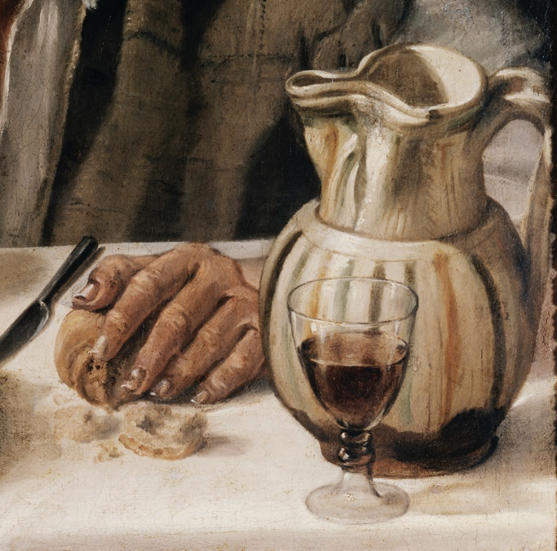

The latency of an evangelical scene in a scene that is at first glance profane in the Beans Eaters must be situated with the founding experiences of Pieter Aertsen (1508-1575) and his pupil Joachim Beuckelaer (1533-1574) who painted an extraordinary Butch Shop. In many market or kitchen interior paintings by these two artists, a small evangelical scene is depicted in the background of the painting, while the foreground is cluttered with a display of food and other household objects as it happens in this Butcher Shop with Fly in Egypt by Peter Aersten (1551). 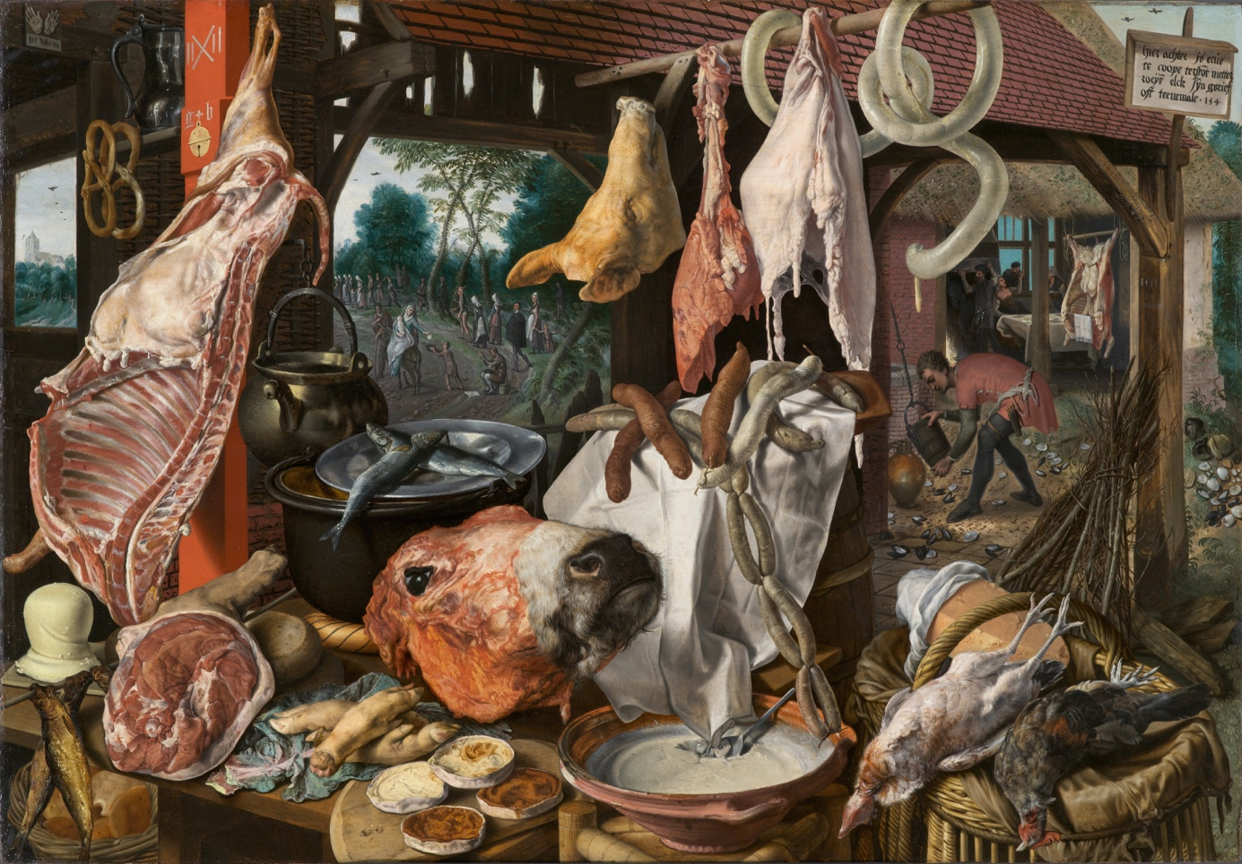

In Annibale’s Bean eaters there is no double image in the sense of two images sharing the surface of the canvas, but a single image that contains a second one that is comparable in some respects to that of Aersten, but superimposed and latent, present only if the connection operation that makes the Emmaus scene appear in the peasant’s meal is activated. I will resume the analysis of this dimension on Wednesday, hoping that, with these examples, I have share the historical and methodological background of my present work.
About Annibale Carracci

Born in Bologna in 1560 and died in Rome in 1606, Annibale was the youngest of a trio that also included his brother Agostino and his cousin Ludovico. The Carracci brothers often worked together and in 1582 founded the Accademia degli incamminati, later renamed dei desiosi. Their activity as painters and teachers met with the profound aversion of the Bolognese painters of the previous generation, Denis Calvaert, Prospero Fontana and Bartolomeo Passarotti. The contemptuous criticism of the unveiling of Annibale's first public work - the Crucifixion we talked about - was recorded by Giulio Carlo Malvasia, I will comment on it on Wednesday. Here it is enough to underline that the series of paintings that interest me can be considered a “painted” response to the criticisms suffered and constitute a sort of pictorial manifesto of the reform that Annibale wanted to promote.
The bad boy – ragazzaccio - as Annibale was called by his detractors - is credited with the invention of caricature and the classical landscape. His writings can be summarized in a few letters and a collection of interesting annotations to the Lives of Vasari.
The two most important biographies of Annibale, that of Bellori and that of Malvasia, are silent on the genre paintings that are part of the series that interests me. There is, however a rich recent bibliography on those paintings
Valérie Boudier, La cuisine du peintre. Scènes de genre et nourriture au Cinquecento. Presses universitaires François-Rabelais, Presses universitaires de Rennes, Tours, 2010.

Giovanni Careri, “Annibale Carracci lo spettatore all’opera”, in L’ora dello spettatore. Come le immagini ci usano, Carocci Roma p. 79-10, 2020
- « Posture et travail mémoriel. Le saint François pénitent de Annibale Carracci » in Frédéric Cousinié et Dominique Boutet (ed.) Im-postures. Langages du corps à l’époque moderne, Paris Ars 1 :1 pp 65-88
- « Un mangeur de haricots à Emmaüs » Geste ordinaire et mémoire rituelle », Studiolo, n. 24 , 2025

Sybille Ebert Schifferer, “Quando mangiare fagioli fa una rivoluzione. Considerazioni su realismo e genere”, in S. Ginzburg, S. Ebert Schifferer, Nuova luce su Annibale Carracci, Roma, De Luca, 2011, p.20-39. 2011

Gail Feigenbaum,“Vulgarity and the Masterly Manner: Annibale Carracci Cites His Sources, in Mitteilungen Des Kunsthistorichen Intitutes In Florenz , LXII Band, Heft 1, 2021
- Practice in the Carracci Academy”, in The Artist’s Workshop: Studies in the History of Art 38, 1993, p. 169-199

John Rupert Martin, “The Butcher Shop of the Carracci”, The Art Bulletin, 45, no. 3, 1963, p. 263-266.

Sheila Mc Tighe, “Food and the Italian genre painting about 1580. Campi, Passarotti, Carracci, The Art Bulletin, vol. 86 n° 2 (juin 2014), p. 301-323

Claude Lévi-Strauss, La voie des masques, Genève, Skira, 1975, vol. 2, p. 117
Yve-Alain. Bois, Denis Hollier and Rosalind Krauss, “A conversation with Hubert Damisch”, October, n°85, 1998, p. 8 ,“A theoretical object is one that is called on to function according to norms that are not historical. It is not sufficient to write a history of this object. It's what I said before: it's not enough to write a history of a problem for that problem to be resolved. A theoretical object is something that obliges one to do theory; we could start there. Second, it's an object that obliges you to do theory but also furnishes you with the means of doing it. Thus, if you agree to accept it on theoretical terms, it will produce effects around itself. While I worked on perspective, I began to have apercus with regard to the history of science that are not at all traditional; I began, that is, to produce theory. Third, it's a theoretical object because it forces us to ask ourselves what theory is. It is posed in theoretical terms; it produces theory; and it necessitates a reflection on theory. But I never pronounce the word theory without also saying the word history. Which is to say that for me such an object is always a theoretico- historical object. Yet if theory is produced within history, history can never completely cover theory. That is fundamental for me. The two terms go together but in the sense in which each escapes the other.”
Giovanni Careri,“Time of history and time out of history: The Sistine Chapel as ‘theoretical’ object”, Art History, 30: June 2007, pp. 326-348., “L’objet théorique entre structure et histoire”, La part de l’oeil, 32, 2019, pp. 13-24, “L’obet théorique art”, introduction à Hubert Damisch et Mathieu Bénézet, Centrer les marges, éditions de l’EHESS, 2025
By focusing on the response of the devoted spectator, my work can be seen as following in the footsteps of David Freedberg, although there are some differences, particularly in relation to the central role of enunciation devices in my approach. Cf. David Freedberg, The Power of Images. Studies in the History and Theory of Response, Chicago, Chicago University Press, 1989.
“Titian's works are not similar to Michelangelo's and therefore he did not like them entirely, but I know this, that they seem alive”, Annibale Carracci, Annotazioni alla Vite di Vasari, Florence, Giunti 1568, MS 4225, Bologna Municipal Library p. 813, see Roberto Benati, Eugenio Riccomini, Annibale Carracci, Catalogo della mostra Bologna e Roma 2006-2007, Milan, Mondadori Electa, 2006. p. 813, note 36,
Something similar to what Michel Foucault describes in Les mots et les choses ,with regard to Las Meninas by Velázquez is produced here: “the scene he describes is sustained, in its existence as a scene, only by the reference it imposes on another scene, established opposite it, and that one invisible, but whose trace, or echo, is found at the center of the painting, in the form of the mirror and the two figures reflected in it"
Emile Benveniste, ‘L'appareil formel de l'énonciation’, Langages,1970, p.12-18
I share this Eucharistic reading of the gesture with Philppe Sohom, “Venetian fingers after Titian”, Artibus Historiae, 41, 2020, pp. 173-194.
Jeremy Koering analyzes profane, pseudo-Eucharistic family or corporative rituals in particular the preparation and administration of wafers printed with images of family emblems during festive ceremonies cf. Jérémie Koering, Les iconophages. Une histoire de l’ingestion des images, Arles, Actes Sud, 2021 English translation : Iconophages. A history of ingesting images, trans. by Nicholas Huckle, Zone Books, New York, 2024, chapter III
https://artsandculture.googlescom/asset/the-butcher-s-shop-joachim-beuckelaer/LAEXA2MqQinLAQ?hl=en

