The Significance of the 'Benin Bronzes' before and after 1897 in the Repatriation Question
Kokunre Agbontaen-Eghafona
Introduction
The Benin bronzes erroneously are not all bronzes, or are they all metal objects. It is the collective name given to Benin cultural objects (made for practical, aesthetical and spiritual purposes) on arrival in Britain in 1897. First, these so called Benin bronzes are numerous collections of cultural objects. These objects are made of clay, metal, ivory, wood, leather, coral, and textile. They include sculptures such as decorated cast plaques, commemorative heads, animal, and human figures; carved ivory tusks; items of royal regalia, and personal ornaments. The metal objects are more brass of variable composition than bronze (Agbontaen, 1983; Frum, 2022; Gunsch; 2013; Phillips, 2021; Zimmerer, 2021). Bronze is mainly an alloy of copper, tin, and other metals, while brass is an alloy of copper, zinc, and other metals.
Meyerowitz (1943), in Ancient Bronzes in the Royal Palace at Benin, attributed the nomenclature of bronzes to von Luschan, the famous German Professor of ethnology, who, on learning about the loot in 1897, cabled Lagos, to secure part of the booty for the German Museums. He was said to also be one of the first to realize the outstanding value of the object and described them as the …best bronzes,… technically perfect, the casts so good (Meyerowitz, 1943, p.248), von Luschan, in appreciation of these objects, said:
These Benin works notably stand among the highest heights of European casting. Benvenuto Cellini could not have made a better cast himself, and no one has before or since, even to the present day. These bronzes stand even at the summit of what can be technically achieved (von Luschan 1919, p.15).
Furthermore, in London, the objects were also immediately labeled the Benin bronzes, thus identifying them with the traditions most admired by the 19th-century British: those of classical Greece and Renaissance Italy. The misnaming stuck as Benin art headed into public and private collections in Britain and around the world (Frum, 2022, p.4).
These objects were collections found (looted) in and around the palace and in the kingdom of Benin during the British invasion of the kingdom in February 1897. These objects were instantly acclaimed as masterpieces and described as the world's most famous collection of African art (Frum 2022). They are said to have changed the way Europeans saw African art, discountenancing the racist colonial stereotype (Zimmerer, 2021) and dispelling some of the racial myths by Philosophers such as Hume (1770) and Hegel (1837).
Benin objects are of great interest and concern presently, as the subject of repatriating them to Nigeria /restitution to the Benin monarch is a topical issue. It is a topic of global media, especially with regard to colonial loot. The intensity of the return increased in 2017/2018, with the report by Felwine Sarr and Bénédicte Savoy commissioned by French President Emmanuel Macron (Sarr & Savoy, 2018). A series of returns have been made from some museums and private collections. The objects have come to symbolize the broader return/repatriation/restitution and decolonizing of the museums' debate. The question concerned parties are asking is: after restitution, what next? Especially after 125 years of sojourn in foreign museums and private collections where these objects may have been highly valued and given expert care and attention. A brief recourse to the past is necessary to discuss the potential future of these Benin objects.
Background and Methodology to the Study of Benin Cultural Objects
Production and care for objects is a culturally universal phenomenon. Every nation/people occupying a particular space on the globe have its/their unique heritage consisting of a natural and cultural endowment. The desire to collect, take care of, preserve, and even display objects of value is innate in man. People of various cultures have been known to have had ways of collecting and looking after their cultural materials or artifacts of value before the establishment of institutions known as museums (Afigbo & Okita, 1985, Agbontaen-Eghafona & Okpoko, 2004). Cultural objects have a special and protected status because they are invaluable to the people and serve as symbols of identity (Campfens, 2020). People of varied cultures have ways they prefer to relate to their cultural objects. Different groups of people worldwide produce artifacts, usually in synchronization with their environment. When placed in different context, environments, and situation, an object of one culture becomes sterile, empty, and just a work of art (Ardouin & Arinze, 1995).

All over the world, and Africa is no exception, societies engage in an elaborate relation with their material cultural heritage, transmitted from one generation to another and conserved according to varying specific modalities: the safekeeping of precious manuscripts and sacred art objects (Sarr & Savoy, 2018). Many cultural objects now seen as art pieces played more functional roles than mere art pieces to the makers. For example, Andah (1988, p 222) points out that Through the ages, African art was hardly ever solely aesthetic in conception and purpose – but rather variously combined [for] ritual, magico-religious, commemorative, and utilitarian functions.

Human beings have complex material culture and tool use (Larsen, 2012; Tischer 2013). Furthermore, humans collect, take care of, preserve and display objects considered of aesthetic value. This ability is innate and uniquely human. People of various groups world-wide have been known to produce items of utility, and to collect and take care of these items, they desire to preserve some of these objects for posterity (Afigbo & Okita 1985; Agbontaen-Eghafona & Okpoko 2004). Therefore, every nation/people of the world has its/their unique objects of natural and cultural endowment associated with their territory. These objects point to the unique cultural blueprint of occupying a particular global space. Such objects make up the constituent that adds in differentiating a group of people from another. These consist of people's artifacts, with time, become antiquities ands, which with time become antiquities and works of art. According to Onwuejeogwu, Okpu & Ebigbo (2000), all African societies have methods of preserving the things (artifacts, antiquities, and art) used by their predecessors, for example, the kingdom of Benin is associated with their renowned cultural objects dubbed 'Benin bronzes'.
A people's art is said to represent a cultural symbol system, just like the language (Andah, 1988). Art is said to be a way Africans express their artistic perception of nature; the most prominent are oral literature, plastic, graphic art, and music (Andah 1988). Africa is rich in sculptures and rock paintings dating from the Stone Age through the Iron Age to modern times (Onwuejeogwu et al., 2000). Also oral literature (orature) is a prominent work of art. Devises like proverbs, drumming, songs, music, and mnemonics are very common in orature. They serve as sources for historical facts, philosophy, geology, economy, and religion (Onwuejeogwu et al., 2000). The use of oral tradition and memory techniques such as songs, proverbs, genealogies, and antiquities made of bronze, iron, gold, wood, ivory, and clay helps in preserving the history of pre-literate societies. Therefore, artifacts in general (antiquities and works of art, such as rock paintings, sculpture, metal works, and pottery) are source material used in studying the past (Onwuejeogwu et al. 2000). Through Benin art and cultural objects, reconstruction of the past can be achieved (Agbontaen-Eghafona, 2005; 2008; 2017). So much of the reconstruction of the history of the objects production was derived from carefully preserved and passed down oral traditions that were also intertwined with the production of the objects. One of the foremost indigenous Benin historians, Jacob Egharevba, documented many of the traditions forming available secondary sources (see Usuanlele & Falola, 1994)
The Benin Arts and Craft Production under the Guild System
Guilds, locally called Otu produced Benin cultural objects. The origin of the guild system can be traced to the earliest rulers of Benin Kingdom c. A.D. 900-1130, known as Ogiso (Egharevba, 1968; Dark, 1973). Benin traditions as also indicated by archaeological investigations (Connah. 1967; 1975; Ryder, 1977) maintain that prior to the Ogiso era, i.e. before A.D. 900, numerous independent villages existed in close juxtaposition. These villages which later formed the Benin Kingdom have been identified today in areas and streets of Benin City (Omoregie, 1982; Agbontaen, 1992). The Odionwere system, the rule of the oldest man in a given village, underlay the political practice of these villages. There was no central government to unify these various villages. However, one of the rulers of Ivbioto village, who organized a coup to assert his authority over all other thirty-one villages. He claimed his authority came from the skies, hence the name ogie means a ruler, and iso, means the skies). Thus began monarchical rule in Benin (lgbafe, 1975). lgodo was succeeded by Ogiso Ere and to him goes the credit of creating the guild system. Praises are still associated with his name to date such as "Erediauwa" (Ere-strengthened prosperity) the name of the immediate past monarch in Benin City.

According to oral tradition, the guild system began with the effort to make the monarchical system secure (Omoregie, 1992; Agbontaen, 1983). The various villages in the newly established kingdom were not accustomed to the idea of a central government. Portions of products of various professionals within the societies were directed to their village heads without regards for the Ogiso. This act was a threat to the monarch, as it showed that power was still concentrated in the hands of Odionweres and not the Ogiso. Blacksmithing, in particular, was of great importance in this case as the craft existed before the Ogiso monarchy and was the most prominent trade and occupation in nearly all the villages. Iron was used by other professions such as in carving, weaving, pottery, farming and engaging in warfare. It t is believed that the possession of iron must have led to the political exploits of the period. Ogiso Ere’s concern was to organize the craft of blacksmithing so that supplies can be made first and foremost to him as the Ogiso. Therefore, it was concluded that the bid for unity, the desire to ensure power, and the need to organize the economic aspect of the life of the society made Ere embark on creating centrally patronized units for the development of each of these economic activities (Omoregie. 1982, p.15).

The system became known as Otu. i.e. guilds. In general, they were associations in various trades given monopoly rights by the reigning Oba who saw the needs for such groups to produce, market, standardize and attend to their products. The raison d'etre of the system was for each guild to supply some of its products to the monarch, which reflected virtually all aspects of the economic needs of the kingdom. There were guilds of brasscasters (Igun-Eronmwon), carpenters (Igbesamwan), butchers and cattle keepers (Iriemila), ritual specialists and herbal doctors (Ebo), drummers (Ikpema), town criers and land purifiers (Avbiogbe), ceremonial executioners (Odionmwan), royal diviners and physicians (Ewaise), performers of funeral ceremonies for the Oba (Eben), guardians of Oba wives (Eruerie), repairers of the harem (Ibieriye), river due collectors (Iwowa) and even acrobats (Amufi). There were at least sixty-eight guilds among the Edo people (Marshall, 1939). Twelve out of the sixty-eight guilds dealt with arts/crafts. These included; architects, blacksmiths, brass casters, carvers, carpenters, costume designers, cosmetologist, coiffure and wig makers, tanners, sculptors, potters, weavers and cosmetologists (Dark, 1973; Obichere, 1981; Agbontaen, 1983).

Benin kings understood the advantages of forming guild system with monopolistic rights to serve them. In other words, it was a deliberate effort to foster the monarchical institution in Benin. It is believed that the economic support given to the Benin kingdom by the craft guild was one of the basic factors responsible for the survival of the kingdom. Each guild established between c. A.D. 940 until the nineteenth Century gave an obvious economic advantage to the Oba, the Palace, and the entire Benin Kingdom. A few examples of the services from the guilds included the architects and mud sculptors constructing buildings and mud reliefs in the palace and maintenance and polishing of the walls and figures. While the blacksmiths provided iron-based materials needed in the palace, the brass casters' support for the throne was more of recording events (akin to taking photographs or painting pictures). The brass-casters products were not merely works of art and display but a recording of events. For example, when a king passed away, his successor had a brass head for the altar of the late Oba (Agbontaen, 1983).

What the Objects mean to the Benin People
Egharevba (1946. p.6) explained that, In ancient days when the knowledge of books and literature were unknown in Africa, brass-casting or pictorial writing were the only methods for preserving recovery of events in Benin, as a result of her civilization on the banks of the Niger. Oba Erediauwa of Benin (1982, p. 5) further reiterated that What we refer to as works of art were not intended to be works of art in the modern sense… they were made specifically for recording important events in the absence of present-day writing or photography. This practice of 'pictorial writing' is said to date as far back as the 7th Century. Cultural objects which passed for mnemonics included clay figurines, terracotta, wooden objects, iron objects, ivory tusks (with designs and figures), and brass objects. Architectural edifices of mud and clay were also used. Benin brass plaques popularly made between the 16th and 17th Centuries, have been suggested as designed to illustrate concepts or events along the lines of the arrangement of individual figures on the carved ivory tusk (Ezra, 1992). Furthermore, Prince Edun Akenzua, in the same vein, stated:

The works have been referred to as primitive art or simply artifacts of African origin. But Benin did not produce their works only for aesthetics or for galleries and museums. At the time Europeans were keeping their records in long-hand and hieroglyphics, the people of Benin cast theirs in brass, carved on ivory or wood. The Obas commissioned them when an important event took place which they wished to record. Some of them, of course, were ornamental to adorn altars and places of worship. But many of them were actually reference points: the library or the archive. .... Taking away those items is taking away our records or our Soul (Akenzua, 2000, para 2).

Prince Akenzua further cited an event that took place during the coronation of Oba Erediauwa in 1979. There was an argument as to where to place an item of the coronation paraphernalia. This was in order for them to wear the correct vestments and have the appropriate officials present, but fortunately, there was a brass cast of a past Oba wearing the same regalia. Some ceremonies need recourse to brass objects as pictorial writing.
History of pictorial writing in Benin
The practice of 'pictorial writing' in the Benin kingdom dates back to the 7th Century and was part of the family practice of ancestral veneration (Omoregie 1982; 1997a). As early as 600 A.D., oral literature accounts claimed that the Benin people lived in villages headed by elders (Omoregie 1982; 1997a). Each family kept and maintained an ancestral altar or shrine as part of the tradition of remembering their ancestors. Mud and clay figures representing specific ancestors were placed on raised platforms made of clay. Significant objects, such as clay figurines, carved items, and implements associated with specific ancestors, were placed next to the altars to help recall what their ancestor was known for in life. Altars were cared for by the head of the families, who taught family members the meaning of the figurines and associated items. Traditionally, this was how events about the past were passed down from generation to generation in Benin.

Larger villages also had communal shrines that commemorated the collective spirit of the dead leaders and common ancestors who were venerated in ways similar to family worship. This system is believed to have continued into the first dynasty of the Ogiso era (c. 900-1130 A.D.) (Omoregie, 1997b; Agbontaen-Eghafona, 1990; 2005; 2008). During this period, a royal council of men with the hereditary title (Ughoron) existed to ensure the passing on of the oral history and traditions of the Benin people and to oversee the rites relating to ancestors and rulers. The Ughorons were aided in their task by mud sculptures, figurines, and other works of 'art' such as commemorative heads carved in wood. It is also believed that sculptures of individual rulers and other figures were carved or molded with specific identifying marks, which the Ughoron made use of in story-telling (Agbontaen-Eghafona & Okpoko, 2004; Agbontaen, 2008). This period preceded the formation of monarchical rule in the erstwhile Benin kingdom (Egharevba 1968; Onwuejeogwu 1980).

The tradition of ancestral worship at both the family and communal level continued well into the second (present) dynasty. The Ughorons, subsequently translated into the group known as Ihogbes, who performs the same kinds of duties. The veneration of the spirits of the departed ancestors was gradually incorporated into the Benin belief system (Omoregie, 1982; Agbontaen-Eghafona, 2008; 2010). When a Benin man dies, his senior son, upon fulfillment of the necessary mortuary rites, sets up an altar in honor of his late father. If the father himself was a senior son and already had an altar for his own father, his eldest son adds carved staves [or staffs] known as ukhure to the existing altar. Brass bells, known as an eroro are also placed on the altar (Aro ogh’erha). If the deceased was of high rank, commemorative heads of wood or brass, ceremonial swords, and other objects are placed on the altar. The senior son then acts as a priest for his father, interceding through him to the ancestors on behalf of all the descendants (Omoregie, 1997; Agbontaen-Eghafona, 2008).
A second group of ancestors honored as collective ancestors are those believed to be the original settlers in the villages and all the elders (Edion) who lived in the locality and were buried there. All Benin villages have Edion shrines called Ogwedion. In some villages, the local councils held their meetings in the shrines. The Odionwere (oldest man in the village) is responsible for the rites performed at the shrine (Agbontaen-Eghafona, 2005). Founders of villages and wards were revered as communal ancestors. Similarly, the ancestors have significance for the entire kingdom. During the pre-colonial era, Obas had separate altars housed in walled compounds known as ugha. At the time of the British invasion in 1897, about fifteen of these compounds existed. Many of the objects used in religious observances in the past ended up in museums as objects and contributed considerably to a global understanding of Benin culture. Many of the brass objects and other items now viewed as 'art’ by museum curators were mnemonic devices or pictorial writing that aided in the recollection of ancestors and events in Benin history (Agbontaen-Eghafona, 2008).

Brass plaques, popular in the 16th and 17th centuries, were arranged to illustrate concepts and historical events, as did individual figures carved on ivory tusks (Ezra, 1992). The king commissioned artists and craftsmen to record local events throughout the realm. Not surprisingly, when the Europeans first visited Benin, they discovered the likenesses, costumes, weapons, utensils, and other details faithfully recorded in wood, ivory, and brass. The tradition of producing artworks to document historical events contributed to the proliferation of Benin objects. Anthropologist Paula Ben-Amos, a Benin art and culture specialist, has observed the existence of over 900 known brass plaques. She notes that the plaques themselves were considered a sort of pictorial record of events in Benin history, an aid to memorizing oral traditions" and that many provide testimony to court life at the time of Oba Esigie (c. 1504) (Ben-Amos 1980 ; 1988)
Bradbury, the first anthropologist to do extensive ethnographic fieldwork in Benin City during the 1950s and 1960s, observed that much of the artworks removed from Benin in 1897 were in a good state of preservation (Dark, 1973). In fact, there were special caretakers in the palace whose job it was to look after these treasures (Dark, 1973). If such care had not been given, it would have been impossible for valuable cultural materials fashioned before the fourteenth and fifteenth centuries to survive the nineteenth and twentieth centuries and find their places in museums around the world today.

Benin art, therefore, was produced for the overriding purpose of recording historical events—a serious political engagement that necessitated that artists and craftsmen were employed to record local events in the kingdom. It was partly as a result of this practice that brass works and carvings, both in wood and ivory, depicting Portuguese soldiers and their arms have been preserved in museums in Nigeria and outside the country (Agbontaen-Eghafona, 2005). Portuguese, Dutch, French and English travelers visited the Benin kingdom between the fifteenth and nineteenth centuries. Some of their accounts mention Benin art forms, for example, the brass plaques, royal ancestor heads, ivory tusks, and carved pillars (Agbontaen-Eghafona, 2008). The Portuguese themselves were at times represented in the Benin art works. The heads and full figures of Portuguese musketeers with their weaponry are portrayed on many brass plaques and ivory tusks.

Care of Benin Cultural Objects Pre 1897
One of the questions that needed to be answered was, what was the 'museum' or repository before the colonial era? If cultural materials of value fashioned before the fourteenth and the fifteenth centuries not only survived the nineteenth and the twentieth centuries but also found places in foreign museums, it becomes necessary to ask the following questions: (i) where were they kept? (ii) of what value were they to their owners before the Europeans arrived? (iii) How well were the objects preserved? Also, how can we describe the Benin-oriented, or African-oriented museums? If Nigerian museums, as we know them today, are western institutions with colonial orientation, and if the concept of the museum today is universal, they may not be meeting the needs of Africans. Thus, it is necessary to seek ways and means of making museums African-oriented to suit the tastes and needs of Africans. This was the outcry of African museum directors and workers recorded by Decker (1990), who claimed that neglect, ignorance, corruption, and poverty have led to the decay and plunder of hundreds of thousands of objects in West African museum collections (p.108). An African-oriented museum, as suggested, might help in resolving some of the problems plaguing the museums in West Africa. Andah (1988) also mentioned in his discussion the need for an African approach to the anthropology of Africa, a real need for African people to truly rediscover themselves and their cultural heritages.
The word museum may be alien to the Benin vocabulary in that the Benin people did not have a museum designed in modern fashion. Still, the people had institutions/structures to care and display their cultural objects (Agbontaen-Eghafona & Okpoko, 2004). If these institutions/structures did not exist, it would have been difficult in contemporary times for anyone to amass the large quantity of Benin collections in museums worldwide. The British expeditionary forces were said to have described such places as a treasury for objects distinct from those in shrines or altars (see Kaplan, Ukwu & Arinze, 1987). In other words, objects taken away from the Benin palace in 1897 were not only taken from the shrine and altar collection but also from the places which can be described as the museum of the Benin people.
Sample Illustrations
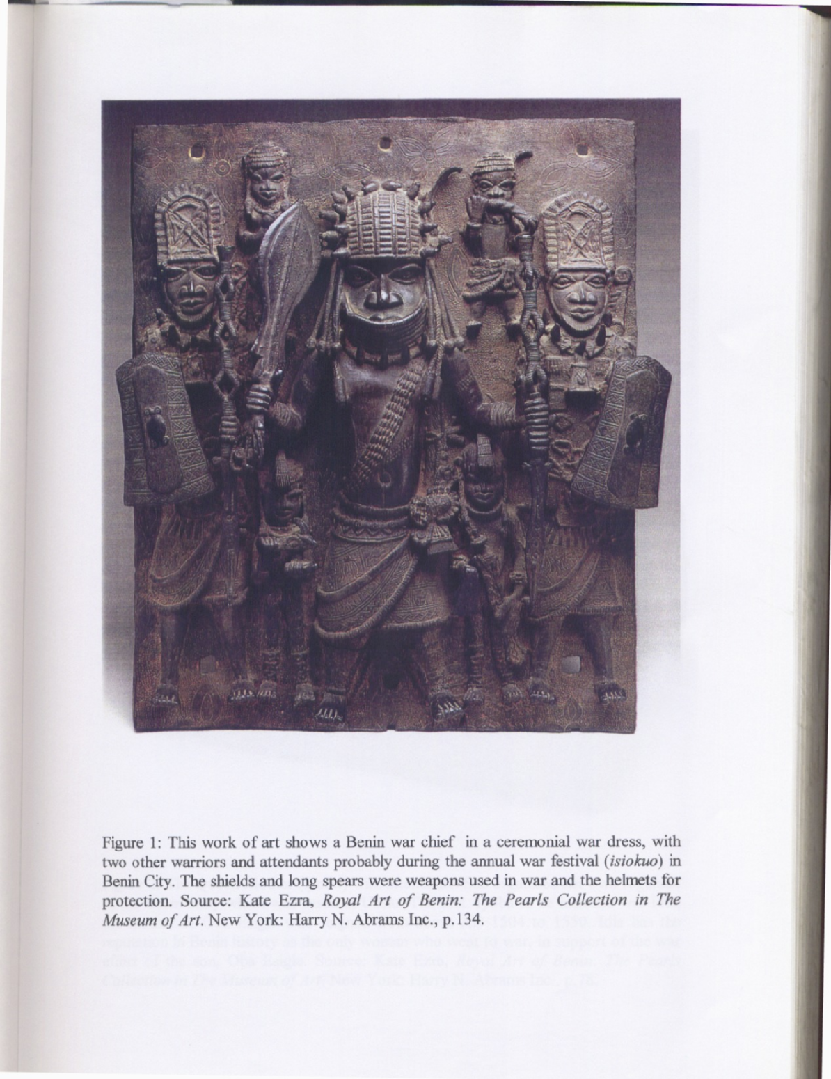
Figure 1: Plaque: Warrior Chief, Warriors, and Attendants. Nigeria, Edo: Court of Benin 16th -17th Century SOURCE: Kate Ezra, Royal Art of Benin: The Perls Collection, in The Metropolitan Museum of Art, New York. Harry N. Abrams Inc. p. 134. 1992.

The figure had also described as Benin war chief in ceremonial war dress, with two other warriors and attendants probably during annual war festival (Isiokwo) in Benin City. The shields and long spears were weapons used in war and elements for protection (Osadolor 2001, p.110).

The figure on the brass plaque has been recognized as Ezomo (generalissimo of the state army and the overlord of Uzebu quarters of the kingdom), specifically identified as the famous Ezomo Ehennua. Well known for his military exploits, Oba Akenzua 1 (1713-1735) made the title hereditary in his honor. The occasion for the casting of the plaque is also recognized during the annual war festival (Isiokwo) (Agbontaen-Eghafona, 2008, p.201).

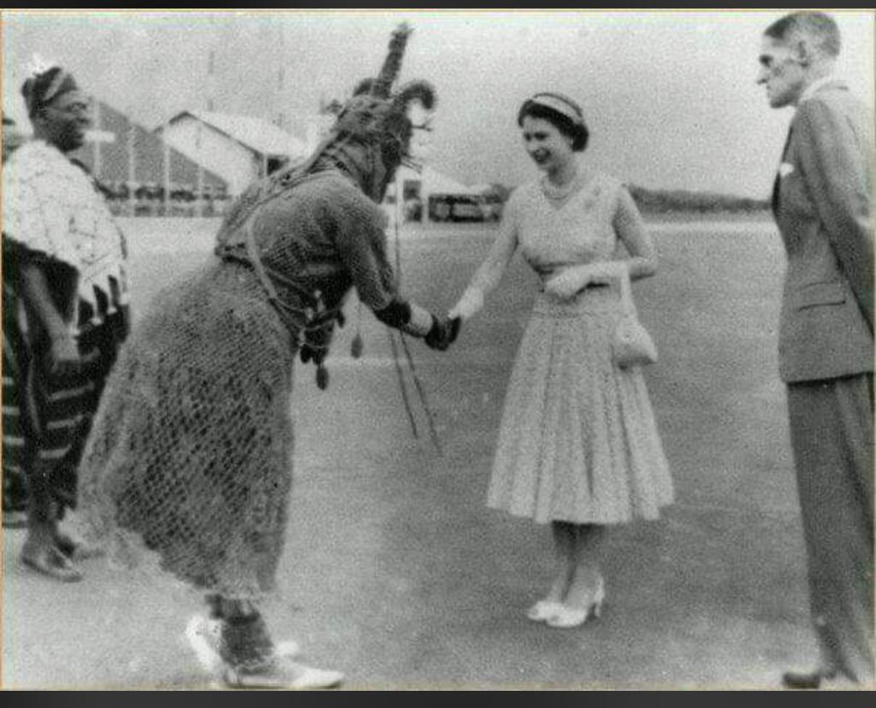
Figure 2: February 1956, when the newly crowned Queen Elizabeth II of England and the Head of the Commonwealth Nations visited Benin, Western Region of the British Colony of Nigeria. Photo by Solomon Osagie Alonge

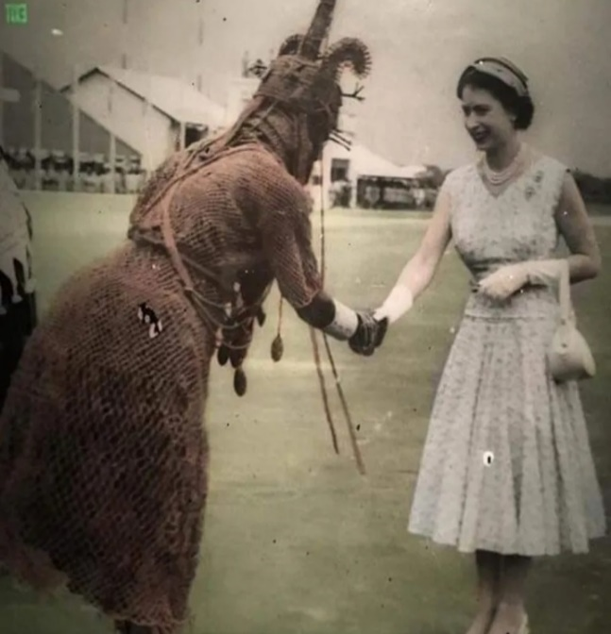
Figure 3: Photograph of Oba Akenzua 11 of Benin and Queen Elizabeth 11 of England, 1956.
Photo by Solomon Osagie Alonge

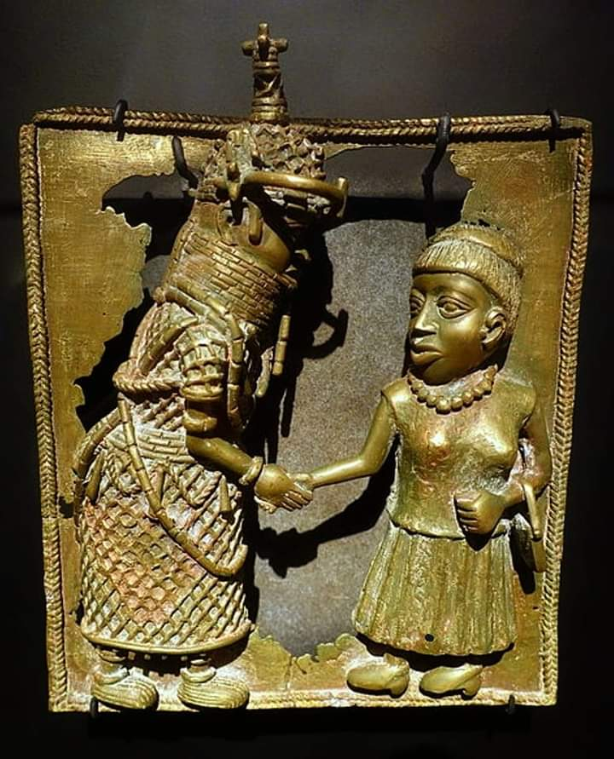
Figure 4: Brass plaque depicting the meeting between Akenzua II, Oba of Benin, and Queen Elizabeth II, during her visit to Nigeria in 1956.
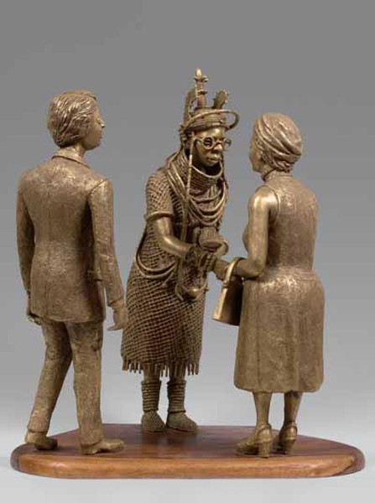
Figure 4: Oba Akenzua II greeting Queen Elizabeth II, Late 20th century. Brass and wood
30 x 45 x 53 cm (11 13/16 x 17 3/4 x 20 7/8 in.) Collection of High Priest Osemwegie Ebohon, Benin City, cn282/ (Description English: Exhibit in the Etnografiska Museet, Stockholm, Sweden. Cast in 2009 by Uyi Omodamwen (donated to the museum in 2010).

References
Afigbo, A.E. & Okita, S.I.O. (1985). The museum and nation building. New Africa Publishing
Owerri, Nigeria.

Agbontaen, K. A. (1983). Benin craft guilds in Time Perspective: A Study of Origins, Development
and Change. (Unpublished master’s thesis). University of Benin.

Agbontaen, K.A. (1990). Benin City arts and craft heritage. Nigerian Magazine. 58, (1 & 2), 3-17.

Agbontaen, K.A. (1992, March). An inventory of archaeological sites in Benin City: A preliminary
survey (Paper presentation). International Conference on Benin Studies 24-28 March 1992, University of Benin. Unpublished manuscript.

Agbontaen-Eghafona K.A. (1997). An Assessment of Four Centuries (15th – 19th) of Benin Art

Production in Evaluating the Role of Craft Guild System on Benin Polity. African Study Monographs October, 18, 45 – 58.

Agbontaen-Eghafona K.A & Okpoko, A. I. (2004) Curatorship of Benin cultural materials:
towards integrating indigenous and orthodox methods. African Study Monographs, 25(4), 195-213.

Agbontaen-Eghafona, K. A. (2005). Recollections of time past: The use of art objects as
mnemonics in Benin history (Paper presentation). Training Workshop on alternative historical sources, memories and history using material culture and archaeological sources as alternative history. Organized by CODESRIA- SEPHIS, 20-26 June 2005, Rabat, Morocco.

Agbontaen-Eghafona, K.A. (2008). Benin Art Objects In Catalogues and Books Interpreting
Conventional Photograph in Indigenous Perspective. West African Journal of Archaeology, 28. (1& 2), 65-77.
Agbontaen-Eghafona, K. (2017). Photographic Recordkeeping in Benin: Ancient and Modern. In
A. J. Staples, F. E. S. Kaplan and B. M. Freyer (Eds). Fragile Legacies: The Photographs of Solomon Osagie Alonge. (97-111). Washington DC: National Museum of African Art, Smithsonian Institution.

Akenzua, E. (2000). The Case of Benin. Appendices to the Minutes of Evidence, Appendix 21,
House of Commons, The United Kingdom Parliament, March 2000.

Andah, B W. (1988). African Anthropology. Ibadan. Shaneson C.I. Limited.

Ardouin C.D. and Arinze, E.N. (1995). Museums and the Community in West Africa African
Museums Programme. International African Institute. London: James Currey.

Ben-Amos P. (1980). The Art of Benin. London. Thames and Hudson,

Ben-Amos, P. (1988). Edo ancestral altars: Testimonies to a life well lived in Proceedings of the
May 1988 conference and workshop on African Material Culture, 20-27 May, Bellagio, Italy. 25-27

Campfens, E. (2020). Whose Cultural Objects? Introducing Heritage Title for Cross-Border
Cultural Property Claims. Neth Int Law Rev. https://doi.org/10.1007/s40802-020-00174-3

Connah, G.E. (1967). New light on the Benin City walls. Journal of the Historical Society of
Nigeria 2, 465-477.

Connah, G.E.C. (1975). The Archaeology of Benin: Excavations and other in and around Benin
City, Nigeria. Clarendon Press Oxford.

Dark, P. J.C. (1973). An Introduction to Benin Art and Technology. Oxford, Claredon Press.

Decker, A. (1990). Lost heritage: The destruction of African art. ART News, 89 (7), 108-119.

Egharevba, J. U. (1946). Concise Lives of the Famous Iyases of Benin. Lagos, Temi-Asuawon Press.

Egharevba, J. U. (1968) A Short History of Benin. Lagos: C.M.S. Bookshop, 1936. (Ibadan:
University of Ibadan Press, fourth edition, 1968).

Erediauwa-Omo n’Oba n’Edo (1982). Speech delivered by Uku-Akpolokpolo Omo’n’Oba
n’Edo, The Oba of Benin at the Exhibition of Lost Treasures of Ancient Benin, 29 April 1982, National Museum, Benin City.

Ezra K. (1992). Royal Art of Benin: The Perls Collection in the Metropolitan Museum of Art.
New York,The Metropolitan Museum of Art.

Frum D, (2022). Who Benefits When Western Museums Return Looted Art? The Atlantic
October 2022 https://www.theatlantic.com/magazine/archive/2022/10/benin-bronzes-nigeria-return-stolen-art/671245/

Gunsch, K. W. (2013) Art and/or Ethnographica? The Reception of Benin Works from 1897–
1935, African Arts, 46 (4), 14-23.

Hegel, G., (1837). General Introduction to the Philosophy of History by Hegel. Marxists.org.
<https://www.marxists.org/reference/archive/hegel/works/hi/introduction.htm
Hume, D. (1779). The natural history of religion. In D. Hume, Essays and treatises on several
subjects, Vol. 2. Containing an enquiry concerning human understanding, A dissertation on the passions, An enquiry concerning the principles of morals, and The natural history of religion (pp. 401–469). Unknown Publisher. https://doi.org/10.1037/11713-004
Kaplan, F.S.; Ukwu N.S. and Arinze E.N. (1987). Nigeria. In V. Jackson (Ed) Art Museums of the
World (pp. 802-822) New York, Greenwood Press.

Larsen C. S. (2012) Essentials of Physical Anthropology (Book 2) W. W. Norton & Company.

Igbafe, P.A. (1975). Slavery and emancipation in Benin 1897-1945. Journal of African History,
16 (3), 409-429.

von Luchan, F. (1901) Die Karl Knorr'sche Sammlung von Benin-Alterumern in Museum fur
Volkerkunde in Stuttgart. Stuttgart.

von Luchan, F. (1919) Die Altertümer von Benin . Berlin and Leipzig.

Marshall, H. E. (1939). Intelligence Report on Benin City. Nigerian National Archives, Ibadan.

Meyerowitz E. L. R. (1943) Ancient Bronzes in the Royal Palace at Benin. The Burlington
Magazine for Connoisseurs, 83, (487), 248-253
.
Obichere B.I. (1981) Benin City and the Royal Patronage of the Arts. In F. Kaplan (Ed)
Images of Power: Art of the Royal Court of Benin, New York University.

Ornoregie. O. S. B. (1982). The evolution of Benin. Paper presented at the Exhibition: The Lost
Treasures of Ancient Benin, National Commission for Museum and Monument, Benin City. 29 April 1982, National Museum, Benin City.

Omoregie, O.S.B. (1991). Benin under the Ogiso Monarchy: Foundations of Edo Civilization,
Vol. 1 & II, Benin City, Neraso Publishers Limited.

Omoregie, O. S. B. (1992) Personal Communication, Benin City

Omoregie, OSB (1997a). Great Benin 2 – The Age of Odionwere (600-900 A.D), Benin City,
Neraso Publishers Limited

Omoregie, OSB (1997b). Great Benin 3 – The Age of Ogiso Foundation (900-1050 A.D,) Benin
City, Neraso Publishers Limited

Onwuejeogwu M. A. (1980). A Study of the Cultural Evolution of Benin Kingdom. IVIE:
Nigerian Journal of Arts and Culture. 1 (2) 18-35.

Onwuejeogwu M.A. Okpu, B & Ebighgbo, C. (2000). African Civilization: Origin, Growth and
Development. Benin City, UTO publishers.

Osadolor, O. B. (2001).The military system of Benin Kingdom, c. 1440 – 1897, (Unpublished
doctoral dissertation) Hamburg University.

Phillips, B. (2021). Loot: British and the Benin Bronzes. Oneworld Publications.

Usuanlele, U., & Falola, T. (1994). The Scholarship of Jacob Egharevba of Benin. History in
Africa, 21, 303-318.

Ryder, A. F. C. (1977). Benin and the Europeans 1485—1897, London, Longmans.

Sarr, F., & Savoy, B. (2018). The Restitution of African Cultural Heritage: Toward a New
Relational Ethics. Ministère de la culture.

Tischler, H.L, (2013). Introduction to Sociology, Cengage Advantage Books.

Zimmerer, J. (2021) Germany is returning Nigeria’s looted Benin Bronzes: why it’s not nearly
enough. August 2, 2021 https://theconversation.com/germany-is-returning-nigerias-looted-benin-bronzes-why-its-not-nearly-enough-165349

