The Problem of Roman Copies: A Transatlantic Dissent
(Preliminary Paper)

The dissent concerning Roman copies has become virulent over the past 30 years, but its starting point lies far back. In order to understand it, we shall have to start from an old book, Adolf Furtwängler's Masterpieces of Greek Sculpture (1893). It was Furtwängler who first proposed Kopienkritik (criticism of copies) as a method. This is where I will begin – but I will also show in what direction German scholarship has modified the methods of copy criticism since Furtwängler. More recently the whole approach proposed by Furtwängler has come under criticism, first in the US, then in Anglo-American academia in general. The starting point was a famous paper by Miranda Marvin, published in 1989. Since then, the revisionist movement has established itself as a kind of new orthodoxy, claiming that the concept of Roman copy should be abandoned as it is discriminatory and denies the creative autonomy of Roman culture; some critics even concluded that Roman sculptors had actually never been producing copies. Furtwängler's position and that of his critics could hardly be more opposite. Nevertheless, a surprising commonality exists between the two: Both share a pronounced disdain for the copy. This disdain is part of modern aesthetics insofar as it is oriented mainly on originality and invention; if we want to gain an adequate understanding of ancient copies we shall have to overcome the blind spots of this aesthetics. But let’s start with Furtwängler.
1. Furtwängler's “Criticism of Copies” (1893)
When Furtwängler published his Masterpieces of Greek Sculpture in 1893, he was not following the trend of the time. In those years, archaeological scholarship was concentrated on the new finds of original Greek sculpture. Furtwängler saw this rather as a step backwards. To his mind the original sculptures found in the excavations were - with rare exceptions - only “works of second or even lower rank” (IX). The central masterpieces of the classical era hat been preserved only in Roman copies: These, he claimed, transmit to us “that selection from the masterpieces of the classical epoch made by the finest ancient taste and connoisseurship. It is the selection of the best and most famous that was possessed in antiquity” (IX). Furtwängler’s implicit premise was rather simple: The works mentioned in literary sources must have usually been famous, and the same is true for the works reproduced in copies. The set of works we know from literature and the set of works that have been actually copied do not have to be completely congruent, but one might expect strong overlaps between them. This justifies the attempt to build a bridge between Roman copies and Greek sculptures mentioned in Roman literature.
Among the sculptures from the Roman period, we can identify groups of statues that show a twin-like similarity to each other: They share the same motif, the same characteristic features, the very same details and folds Fig. (1-2). Furtwängler referred to the pieces belonging to such a group as “Repliken”, replicas and regarded them as copies deriving from one and the same model. Since the common features stylistically looked pre-Hellenistic, Furtwängler concluded that the copied models had been masterpieces of the Greek classical period. By comparing all the replicas of a group, Furtwängler tried to arrive at a reconstruction of the lost model. The method he used for this he called “Kritik der Kopieen” (IX and X), criticism of copies. The term itself was a neologism, referring unmistakably to philological textual criticism, as it had received a firm methodological foundation around the middle of the 19th century. Textual criticism as a methodological procedure based on medieval and early modern manuscripts of a given ancient text in order to recover the wording of the lost original. Furtwängler used this as a model for his copy criticism.
But his ambition went further. He wanted not only to reconstruct the models, but also to attribute them to certain artists. For such attributions, Furtwängler resorted to a completely different methodological model. A few years earlier, Giovanni Morelli had developed a new method of attribution in the field of Renaissance painting. Morelli based his attributions on small details such as the drawing of a hand or an ear. Accordingly, Furtwängler now also tried to determine the individual style of Greek sculptors on the basis of small details. The following description refers to two heads in which Furtwängler believes to recognize the signature of the sculptor Myron: “Quite Myronian is [...] the formation of the eyelids and of the lacrimal caruncle, the downward protruding forehead, the round structure of the skull and the faint incision in the neck”. In this way, Furtwängler has been able Inv. Hm to link an astonishing number of copies to the oeuvre of certain Greek sculptors of the 5th and 4th centuries.
This did not convince all contemporaries. Reinhard Kekulé, for example, complained as early as 1895 that Furtwängler had put the cart before the horse. Before one looks for characteristics in Roman copies in order to attribute the copied works to Greek sculptors, “we would have to clarify to which periods and which workshops these copies belong and to what extent these stylistic details coincide with the habits of certain periods and workshops” (641). Thus, he said, it would first be necessary to clarify the history of Roman copies as copies, to arrange them chronologically and according to workshops. Kekulé added that this would be “a very laborious, [...] but [...] not hopeless work.” Indeed, Morelli had been dealing with original paintings and drawings; Furtwängler, on the other hand, was working with copies, without clarifying whether the details he was looking at were due to the copyist or to the creator of the original. Kekulé was criticizing Furtwängler's method of attributions, but not his copy criticism in the narrower sense. Both approaches are methodologically independent of each other, and independent are also the results obtained: It is possible and legitimate to do copy criticism without even considering the question of master attribution.
Since the late 1960’ies German scholars have systematically taken up Kekulé's suggestion to understand copies as a genre within Roman art production. In doing so, they have been able to show that exact copies are just one special case within a much broader group of materials; constant element of such materials (often termed as Römische Idealplastik) is a recourse to contents and forms of the Greek classical period - which, however, can be realized in many very different ways. Here are just three examples.
First, careful copying is quite compatible with radical changes. For example, there are statues that copy a classical model exactly, but then combine it with a contemporary portrait head (Fig. 3). Secondly, a Roman workshop, without copying a specific model, can take up the general habitus of a past epoch - or even combines, e.g. in a group, heterogeneous styles with each other (Fig. 4: here the style of the early 5th century on the left, of the late 5th century on the right).
The third case is particularly important in our context. It concerns figures that share certain general characteristics, but without matching in detail. The three statues you see (Fig. 5-6) have all their weight on the right foot; the mantle is tied with a fibula above the right shoulder; the part of the mantle falling down the back is pulled to the side and passed over the left forearm. Despite their similarity, these statues are not replicas: There is no correspondence in detail between them; they were merely all made according to one and the same general pattern or recipe.
Let us summarize. The spectrum of Roman ideal sculpture is more varied than Furtwängler had thought. Roman classicism is a multifaceted phenomenon and should be understood as a remarkably self-confident form of appropriation: There can be no question of slavish imitation. Copying also will have to be interpreted in this light. But first we have to deal with the claim that in Rome there was no copying at all.
2. Miranda Marvin’s rejection of Furtwängler’s Kopienkritik (1989).
In 1989 Miranda Marvin published a revolutionary essay on Copying in Roman Sculpture. As a starting point she focused on the question why Roman customers were interested in Greek. Furtwängler had implicitly assumed an audience of connoisseurs who would be able to recognize the style of classical works of art and appreciate the fidelity of copies. To test this assumption, Marvin reaches back to some letters Cicero wrote in the 60s of the 1. century BCE. Shortly before, Cicero had purchased a villa in Tusculum and was planning to design part of the garden in the form of a gymnasium; in this context, he writes to his friend Titus Pomponius, called Atticus, who had been living in Greece for many years, asking him to buy for him sculptures that would fit a gymnasium - ornamenta gymnasiode. On this Marvin notes: “Cicero tells Atticus what sort of sculpture to buy, not by describing the artist or the style or [...] the subjects that he wants him to look for, but by describing the location where the works are to be placed” (31) and she continues, “ Cicero did not ask for replicas of specific works, only for the 'generic brand' of gymnasium statuary” (32) This, Marvin claims, can hardly be reconciled with the assumption of profound art connoisseurship. “One Roman purchaser at least can be clearly shown to have been interested in sculptures appropriate for specific settings but to have left no sign of wanting copies of particular Greek originals” (40). If Cicero was not an isolated case, where would be the audience eager to acquire statuary copies based on classical models?
Let’s look at the argument more closely. Indeed, Cicero agrees to the purchase of statues at the price of 20,400 sesterces, referring to them very generically as Megaric statues (signa Megarica), without saying a word about their subject or style; he does not even mention the number of the statues. But does this really speak for aesthetic indifference? I would like to challenge this. We have to consider that only Cicero's letters survived; Atticus' letters are all lost. This is relevant not least for the understanding of signa Megarica, which is not a common term that would inherently have a definite meaning: there were no marble quarries at Megara, nor was the city known for its stonemasonry. When Cicero speaks of signa Megarica, he quotes a formulation of Atticus, to whose letter he explicitly refers (“ut tu ad me scripseras”; “de quibus ad me scripsisti”). In this letter (that has not been preserved) Atticus will certainly not only have mentioned the number of statues; he will also have specified what kind of statues they were; he might even have mentioned names of artists. The claim that Cicero decided to buy these statues from Megara without having any information about their subject and style, even more: without wanting to have such information - this claim is hardly covered by the evidence. For us, the signa Megarica remain indeterminate simply because we lack Atticus' letter about them; and, of course, Cicero’s letters are of little help: Cicero had no reason to repeat in his letters what Atticus had previously written to him.
There is one further point to consider. In the same letters, Cicero asks Atticus for another favour: “I want you to consider how you might put together a library for me.” This is about the purchase of papyrus scrolls of Greek literature, which are easier to obtain in Athens than in Rome. Again, Cicero does not mention any names of authors or specific titles. Should we conclude from this that Cicero was indifferent or lacked competence in literary matters? Certainly not! Cicero simply does not give more specifics because he can rely on the fact that Atticus and he both share the same canon, they value and appreciate the same texts. It is not for nothing that he invokes Atticus' humanitas - an interesting concept that oscillates between friendliness and education. It is reasonable to assume that the case of shared values applies also to the project of buying ornamenta gymnasiode. In reference to the sculptures Cicero explicitly emphasizes his trust in Atticus' elegantia- a term that pretty much covers what Furtwängler understood by “taste and connoisseurship.” Cicero could rely on Atticus as a friend and connoisseur.
Nevertheless, Marvin is perfectly right in stressing the fact that Cicero considered the sculptures he was about to buy primarily as ornamenta, intended to characterize a part of the garden of his villa in Tusculum as a gymnasium. This attitude, she argues, is indicative of the Romans' interest in art more generally, beyond the individual case; “the function of sculpture is to suggest the character of the space in which it is set.”
At the end of her essay, Marvin once again contrasts her and Furtwängler's approach: “Two hypotheses have been put forward to explain the replica series. One could be called the 'copy' and the other the 'programmatic' hypothesis.” The first hypothesis considers replicas as copies after a famous model, the other insists that Roman statues served primarily a semantic - Marvin would say programmatic - characterization of their place of installation. “The explanation suggested for a large replica series is that it represents a tribute to the usefulness of the type in a variety of Roman sculptural programs. Figures such as, for example, Aphrodite or Heracles [...], are the subjects that survive today in the greatest numbers. The particular sculptural types chosen were those capable of conveying the desired meaning more clearly, those everybody knew.” Duplicated in series, the Romans would thus have produced “a handful of works whose meaning was instantly clear to everyone, the visual equivalent of a cliché.”
It is important to realize that the two approaches addressed by Marvin are not mutually exclusive hypotheses; they are complementary modes of interpretation. The two hypotheses refer to two different levels on which an ancient viewer could ascribe meaning to sculpture -and these two levels are by no means mutually exclusive. Even if the signa megarica acquired by Cicero had all been copies based on classical athlete statues, this would not have detracted from their function as ornamenta gymnasiode. And vice versa - from the fact that they were bought as ornamenta gymnasiode, one should not conclude that they could not have been copies.
In addition, Marvin's “programmatic hypothesis” fails to explain the decisive characteristic of Furtwängler's replica series. The replicas of one type resemble each other not only in the general, significant features, but also in the smallest formal details. The Roman sculptors obviously aimed at preserving the entire complexity of the respective type, without letting details fade away. Marvin fails to recognize this when she refers to the statuary type as the visual equivalent of a cliché. The advantage of a cliché or a stereotype lies precisely in the reduction of complexity: the simpler a figure, the easier it is to memorize and replicate. Had it been only a matter of clichés, the sculptors could have been content with the summary reproduction of just a few simple patterns.
To my mind, Marvin's attempt to refute Furtwängler's is hardly convincing. Nevertheless, it has had a huge impact first in the US and then in the whole of Anglo-American-Academia, giving rise to a wide spread general rejection of the criticism of copies. The consequences of this I shall examine in my talk.

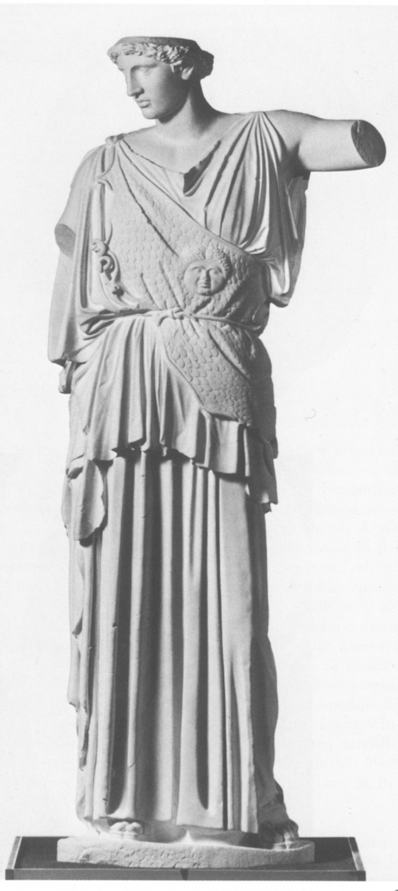 | 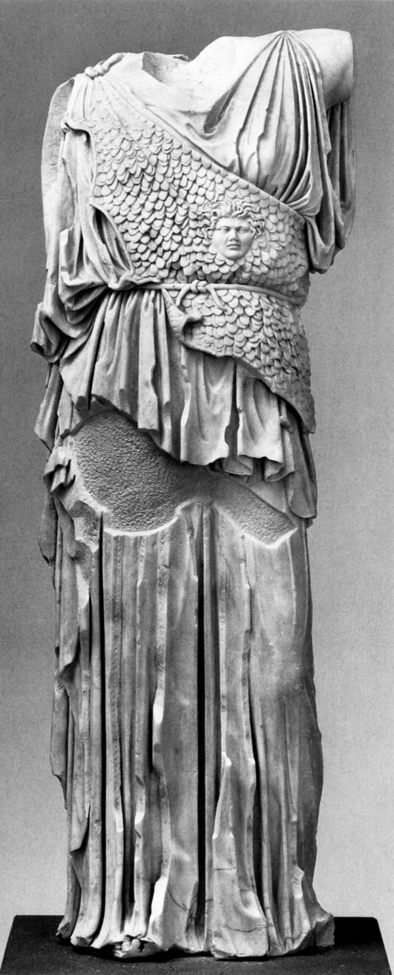
Fig. 1 | Fig. 2

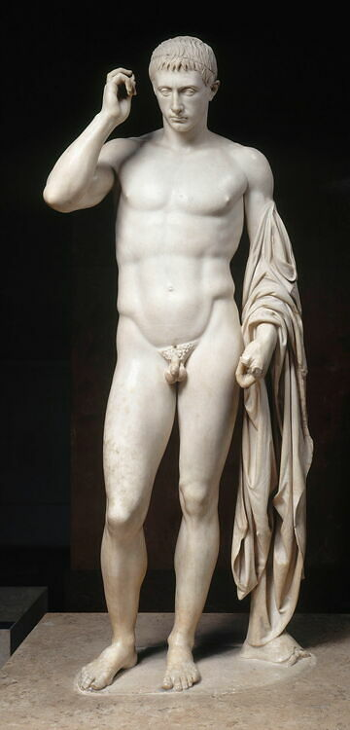 | 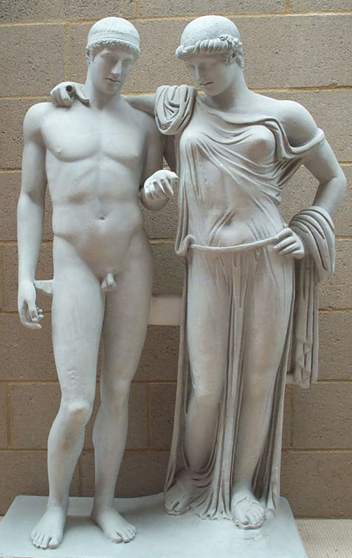
Fig. 3 | Fig. 4

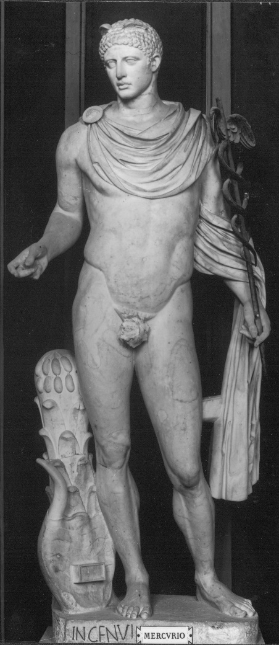 | 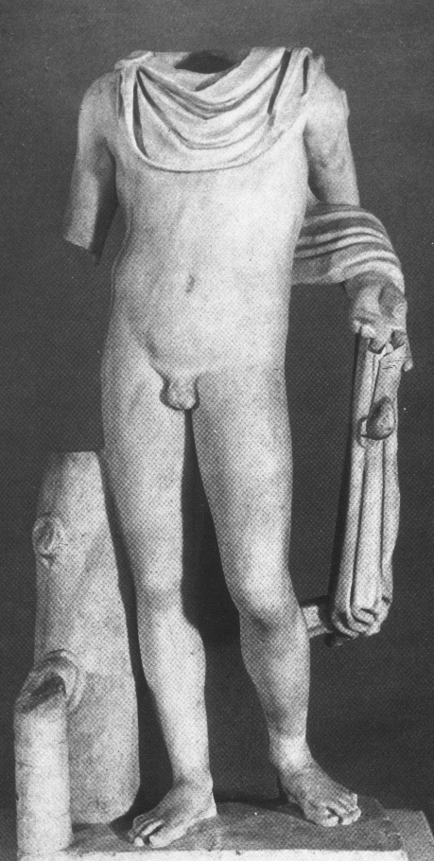 | 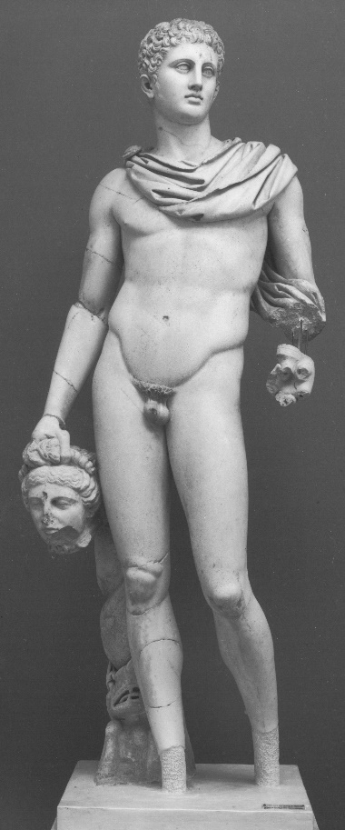
Fig. 5 | Fig. 6 | Fig. 7

See, e.g., the two statues of Athena: Dresden, Inv. Hm 49 and Kassel, Inv. Sk 2; cfr Furtwängler 1893, 4-8.
Furtwängler 1893, 352, referring to plates XVII and XX.
Kekulé, GGA 1895, 625-643.
Paris, Louvre, Ma 1207, “Marcellus”.
Napoli, Museo Archeologico, Inv. 6006.
Mercurius Ingenui, Rome, Musei Vaticani; Apollo Virunum, Klagenfurt; Perseus Ostia, Mus.Ost. Cfr. Ch. Landwehr, Konzeptfiguren. Ein neuer Zugang zur römischen Idealplastik. Jahrbuch des Deutschen Archäologischen Instituts 113,1998, 139 (Abb. 23, 21, 29).
M. Marvin, Copying in Roman Sculpture: The Replica Series. In: K. Preciado ed., Retaining the Original: Multiple Originals, Copies and Reproductions. Washington D.C. 1989, 29-45; repr. in: E. D’Ambra ed., Roman Art in Context. An Anthology. Englewood Cliffs 1993, 161-188.
Cic. Att. 2,2.
Cic. Att. 4,2.
Cic. Att. 4,2; 5,2.
Cic. Att. 3; see also 6,4.
Cic. Att. 3.
Cic. Att. 4,2.
Marvin 1989, 33.
Marvin 1989, 40.
Marvin 1989, 36.
Marvin 1989, 34.

